**Design Project­**

**MECH 323 Machine Design (Winter 2021)**

|  |  |  |  |
| --- | --- | --- | --- |
| **Team Number** | **44** | | |
|  | | | |
| **Phase Number** | **2** | | |
|  | | | |
| **Team Members** |  | **Student Number (Required)** | **Student Name**  **(Optional)** |
| **1** | **20113369** | **Vanessa Noel** |
| **2** | **20116486** | **Owen Cox** |
| **3** | **20054130** | **Nikita Ravindran** |
| **4** | **20114391** | **Alexander Parks** |
| **5** | **-** | **-** |
|  | | | |
| **Mark** |  | | |

*Statement of Originality: “The title page containing the name above asserts that this is a wholly original work by the author, and any shared and external contributions to this work are documented within.”*

Table of Contents

Executive Summary 2

1.0 Preparation 3

Design 3

Updated design 3

1.1 Section 1: Fatigue Analysis of a Steel Bar 5

Task 1: Construct an S-N Diagram for the Steel Bar 5

Task 2: Life Cycles for a Steel Bar Under Alternating Stress 7

1.2 Section 2: Gear Design for Bending and Contact Fatigue Failure 8

Equations for calculating factors 8

Results from analysis 11

Conclusion 12

Appendix A – Design Parameter Table 14

Calculated Design Parameters 14

Phase 2 Section 2 - Bending/Contact Strength, Stress and Safety Factor 14

Appendix B – Code 15

Appendix B – Updated Drawings 18

Appendix C – Excel Spreadsheet calculations 21

# Executive Summary

The goal of Phase 2 was to modify and improve the previous gearbox design. Using fatigue analysis, the bending and contact fatigue failures were calculated and modified using correction factors. These correction factors ensured that the calculated values were accurate. The S-N diagram showed that the initial fatigue strength was 600MPa. At cycles, the fatigue strength was 540 MPa, and at cycles, the fatigue strength was 300 MPa. After factoring in all additional constants, the corrected endurance limit, was determined to be 299.23 MPa. Under alternating stress, the number of cycles the steel bar could withstand before failure was found to be .

In the following section, the analysis for both the bending and contact failures was performed for our designed gearbox. Using this analysis, the corrected bending, contact stresses, bending strength, surface fatigue strength, and the safety factors against bending and contact fatigue were determined. The safety factor against bending was found to be 8.79 for the pinion and 11.41, for the gear. It should be noted that both values are quite high indicating that they are both, extremely safe and durable. Moreover, the safety factors against the contact failure were found to be 1.36 for the pinion and 1.28 for the gear. Both the pinion and the gear have a factor of safety well above the minimum of 1.00.

# Preparation

The primary goal of Phase 1 was to design a gearbox that would meet performance requirements in two events- the top speed event and the hill climb event. The optimal gear ratio calculated was 2.9. After re-evaluating the original design, the team decided to modify it such that, the gearbox would now feature a two-stage shifting gear set instead of the originally planned one-stage. This dramatically improved the vehicle's performance and ensured that it will meet all the requirements. Furthermore, this new design enables the vehicle to better adapt to each of the events meaning the team will be able to score higher.

In this phase, the team incorporates some improvements to the design as well as, improved the justification and validation of the design based off the feedback received from phase one. Please note, Table 1, in the appendix details the design parameters from Phase 1 and includes all revisions (which takes into consideration the modifications made to the gear set).

## Design

At the end of Phase one, the team had designed a working gearbox that satisfied the criteria set forth by the rubric. The primary objective was for the car to be able to reach the maximum angle of 27.47 degrees while still ensuring a reasonable top speed was achieved. The original design consisted of a single-stage gearbox, with a single pinion and a single gear of 18.75- and 55-millimeter diameters, respectively. This resulted in a gearbox ratio of 2.9.

In Phase 1 the gear ratio was found for the purpose of scoring maximum points in the hill climb event. Based on calculations the team had done, it was determined that to reach the maximum possible angle, the car would need to accelerate within five seconds. After a range of gear ratios that fit the criteria was found, the ratio with the highest top speed was chosen. This ensured the team would perform extremely well on the hill climb event and still achieve a reasonable top speed for the race.

While the design met all the expectations, there were several ideas and possible improvements that were discussed but set aside due to time constraints. The team decided to update the design in phase 2.

## Updated design

The advantage of a shifting gearbox is its ability to use 2 different gear ratios for separate events. A lower gear ratio could be chosen for the speed event. This reduces torque in favor of increasing the RPM. The gearbox could then be shifted to a higher gear ratio which in turn, would increase the torque for the hill climb event.

With the calculations made in phase 1, the range of gear ratios that allowed the car to reach the maximum angle were found. This range was 2.2:1 to over 7:1 for a mass of 15 kg, however, to make the gearbox single stage, a range of 2.2:1 to 2.9:1 was chosen for the hill climb event.

As seen in the calculations from phase 1, the minimum torque required to overcome the rolling resistance on a flat surface could be found with the use of an FBD of the car. This torque would then be the stall torque of the motor. It was found to be 0.625 Nm for a mass of 15 kg and 1.125 Nm for a mass of 18.75kg. With the maximum torque of the motor assumed 2.0 Nm, the highest gear ratios that resulted in a stall at the maximum motor output were found to be 0.3125 for 15 kg. An additional safety factor of 1.2 was used to account for frictional losses and losses in output power from any imperfections in the power supply. The resulting torque was found to be 0.75 Nm and a gear ratio of 0.375 for a mass of 15 kg.

Where the torque required is multiplied by a factor of safety to get the minimum torque needed to be produced by the gearbox. A high factor of safety was used because if the real stall torque is less than predicted, the calculated top speed would be an underestimation. However, if the real is higher than the predicted stall torque, the rolling resistance will not be overcome, and the car will not be able to accelerate.

Gear ratio, [Lecture 2, Slide 12]

With the discovered stall gear ratio, it can be assumed that any higher gear ratio would result in excess torque, which in turn would accelerate the car. As the car accelerates, the RPM of the motor increases until the new stall torque is reached. This is the point where the car stops accelerating and moves at a constant velocity. The new stall torque can be found using the gear ratio and with the same minimum torque due to rolling resistance in the equation above, rearranging to solve for the pinion torque. The corresponding RPM could then be estimated with the motor – torque curve, and finally, the RPM of the rear axle can be found using the equation above once again. The spreadsheet with all the top speeds can be found in Appendix C (Figure 10).

With a factor of safety of 1.2 range of gear ratios for the top-speed event was found to be 0.38:1 to 0.6:1, where the top speed started to decline.

The final gear ratios were chosen to be 0.4:1 for the speed event and 2.5:1 for the hill climb event. With a high gear ratio of 2.5:1, the car is expected to climb to a 27.47-degree incline in well under 5 seconds. The 0.4:1 low gear ratio is estimated to allow the car to reach a top speed of 0.817 to 1.224 m/s, with an assumed factor of safety between 1.2 and 1 respectively.

# Section 1: Fatigue Analysis of a Steel Bar

Fatigue analysis is used to validate designs by ensuring that a given part has the structural durability required to withstand the forces it will endure during its life cycle. Parts that are subjected to variable loading over their life cycle are especially prone to failure at stresses well below the ultimate yield strength due to fatigue failure. This means fatigue analysis is especially critical in cases where the part(s) need(s) to withstand cyclic or variable loading over their life span.

An example of when fatigue analysis is especially useful is when testing shoes. Shoes should be able to withstand the force of someone running, walking, etc. To ensure the shoes can endure this type of stress and still provide the necessary support for several years, shoe companies use fatigue analysis to test them. They simulate someone running or jumping in the shoes using special machines. An example of such a machine can be seen in a video [1]. The machine in this video claims to be able to measure the “long-term fatigue behavior of a shoe,” as well as many other things. In this case, fatigue analysis could be used to validate that the shoe can not only withstand the required force without permanent deformation but also ensure the longevity of the shoe (e.g., the stitches not being undone, sole not separating from the base of the shoe, still being able to provide adequate support even after hundreds of uses, etc.). This is just one of many ways fatigue analysis could be used to validate a design.

Before reading the sections below, it should be noted that there were a few key assumptions made for the following calculations. These assumptions were that the load being applied for all the cycles is the same and constant and that after the point at which permanent deformation occurs, the constants that were calculated still hold.

## Task 1: Construct an S-N Diagram for the Steel Bar

The team’s first task was to construct an S-N diagram, which is a visual representation of how the strength of a material changes with fatigue cycles. The given information stated that initially, the fatigue strength of the bar was Since the bar was subjected to bending loading, the fatigue strength at cycles are . Once the bar reaches cycles, it hits the endurance limit. As stated on slide 15 of lecture 10, the uncorrected endurance limit for steels is for values of That means the uncorrected endurance limit in this case is . A summary table with all these values is below (Table 1).

|  |  |  |
| --- | --- | --- |
| **Label** | **Cycle Number** | **Fatigue Strength [MPa]** |
|  |  | 600 |
|  |  | 540 |
|  |  | 300 |

Table 1 - Summary of Values Needed for the S-N Diagram

It is also worth noting that an assumption is made that the fatigue strength remains constant between each of the stated cycle numbers in the table above.

To find the value of the corrected endurance limit ( several constants need to be calculated. Most of these constants were either given in the instructions or could be found using the equations in the textbook. Using the textbook, the values of [table number 6-4], = 1 [equation 6-25], [table 6-2], and = -0.217 [table 6-2] were found. The value of was a given. On slide 14 of lecture 10, it states that can often be set to one because it is often not available, in this case, the team has chosen to set it as one. The remaining constants and were calculated using the equations given in the lecture slides. Below are the equations and calculations for , , and .

Surface factor, [lecture 10, slide 9]

Equivalent diameter

Size factor, [lecture 10, slide 10]

Corrected endurance limit, [lecture 10, slide 7]

= 299.23 MPa

To summarize these findings and make them easier to read, they have all been put in the table, below (Table 2).

|  |  |  |
| --- | --- | --- |
| **Constant** | **Value** | **Explanation** |
|  | 0.759 | Face condition- accounts for rougher surfaces |
|  | 2.103 | Size factor- accounts for specimens being small when lab tested |
|  | 1 | Load factor- accounts for other loads, like axial or torsional loads |
|  | 0.786 | Temperature factor- accounts for the change in tensile strength between room temperature and operating temperature |
|  | 0.814 | Reliability factor- accounts for the accuracy of testing results for endurance limit |
|  | 1 | Miscellaneous effects factors- any effects not accounted for in the above |
|  | 3.04 |  |
|  | -0.217 |  |
|  | 300 | Baseline endurance limit |
|  | 299.23 | Corrected endurance limit |

Table 2 - Summary of Needed Constants for Corrected Endurance Limit Calculations

Using all the values mentioned above, the S-N diagram was created. The S-N diagram can be found below, in Figure 1.

Figure 1- S-N Diagram for the Steel Bar

Please note, the above diagram and all the calculations for it were generated using Python. The code for these equations and the diagram can be found in the appendix (Figure 2 and Figure 3).

## Task 2: Life Cycles for a Steel Bar Under Alternating Stress

The goal for task two was to calculate the number of life cycles the steel bar would withstand if it were subjected to an alternating stress of 150 MPa. Using the given equation for Y, the equation was rearranged and isolated for X.

cycles

Using a python document (this code can be found in the appendix), the value of X was calculated as cycles. This means that the part can withstand cycles before failure. The significance of this value is that it indicates the part is extremely durable and that it can potentially be used for years (depending on how many cycles it goes through in a year) before failure occurs. The larger the X value, the longer the part can be in use before it needs to be serviced or replaced.

# Section 2: Gear Design for Bending and Contact Fatigue Failure

Bending and contact fatigue failure analysis was performed for both the gear and pinion. The purpose of this analysis was to determine the safety of the gearbox. The overall goal of our design is to have safety factors for bending and contact fatigue both above 1 for the gear and pinion.

The first step in fatigue failure analysis is setting up all the equations and determining each of the factors required for the analysis. These equations were then used to determine the safety factor against bending and contact fatigue. The factors are determined over a life cycle of 5 years, with constant 24/7 usage.

## Equations for calculating factors

Safety factor against bending fatigue failure, [Lecture 14, Slide 5]

Safety factor against contact fatigue (pitting) failure, [Lecture 14, Slide 5]

Corrected Bending Stress [Lecture 14, Slide 6]

Corrected Contact Stress [Lecture 14, Slide 5]

Corrected bending strength [Lecture 14, slide 8]

Corrected surface fatigue strength [Lecture 14, Slide 9]

(Uncorrected) Published bending strength, [Lecture 14, Slide 10]

(Uncorrected) Published surface fatigue strength

Stress cycle factor for bending stress

The table below summarizes what the values of the above variables are and how they were found. Most of the variables were either given or were found in various tables in the textbook. The remaining variables needed to be calculated. Those calculations can be found under the table.

|  |  |  |  |
| --- | --- | --- | --- |
| **Variable** | **Pinion** | **Gear** | **Explanation** |
| Tangential transmitted load, Wt [N] | 33.68 | 33.68 | Calculated in Phase one |
| Overload factor, KO | 1 | 1 | Used “to make allowance for externally applied loads in excess of the nominal tangential load” [Lecture 14, slide 12]. *Ko*is 1 for an electric motor driven by a uniform machine |
| Dynamic factor, Kv | 1.024 | 1.061 | The factor for manufacturing errors and inaccuracies including vibration and small dynamic impacts [Lecture 14, Slide 13]. |
| Quality index number, Qv | 3 | 3 | *Qv*is the quality index number (Transmission accuracy-level number) determined from Table 11-6 [Lecture 14, Slide 14]. The *Qv*used for our gearbox is 3. |
| Size factor, KS | 1 | 1 | To account for the non-uniformity of material properties due to size [Lecture 14, Slide 15]. There is no effect of size for our gearbox so a *KS*of 1 is used. |
| Face width of narrower member, b [mm] | 10 | 10 |  |
| Module, m [mm] | 1.25 | 1.25 |  |
| Load distribution factor, *KH* | 1.6 | 1.6 | Accounts for non-uniform load distribution over the face width [Lecture 14, slide 16]. |
| Rim thickness factor, *KB* | 1 | 1 | If the thickness of the rim is too small, the bending failure may occur through the rim [Lecture 14, slide 17]. The factor depends on the backup ratio which relates the rim thickness with the gear size. A KBof 1 is chosen for our gears because the backup ratio is less than 1.2. |
| Geometric Factor for bending, *YJ* | 0.25 | 0.37 | A modified form of the Lewis form factor which can be looked up in figure 14-6 given in the slides [Lecture 14, slide 19]. The *YJ*used for the gear is 0.37, and the *YJ* used for the pinion is 0.25. |
| Elastic coefficient, *ZE* | 191 | 191 | Uses Table 14-8 in the slides [Lecture 14, slide 20]. For a steel pinion and gear, ZE=191√MPa. |
| Surface condition factor, *ZR* | 1 | 1 | Accounts for surface roughness [Lecture 14, Slide 21]. ZR = 1 for conventional gears. |
| Geometry factor for pitting resistance, *ZI* | 0.13 | 0.13 | Accounts for geometric effects on pitting resistance [Lecture 14, slide 22]. |
| Pitch diameter of the Pinion, *dwl* [mm] | 18.75 | 18.75 |  |
| Temperature factor, | 1 | 1 | For temperatures <120℃, [Lecture 14, Slide 24]. |
| Reliability factor, *YZ* | 1 | 1 | Accounts for statistical distributions of material failures [Lecture 14, slide 25]. With a 0.99 reliability, *YZ*= 1. |
| Stress cycle life factor for pitting, *ZN* | 0.52 | 0.49 | Allows adaptation of contact strength based on overall load cycles |
| Stress cycle factor for bending, *YN* | 0.7 | 0.637 | Used to modify bending strength if cycles vary very greatly |
| Hardness ratio Factor, *ZW* | 1 |  | Accounts for hardness difference between gear and pinion [Lecture 14, slide 27]. *ZW* for our gear and pinion is 1 because they are made of the same material, so they have the same hardness. |

Table - Summary Table for All Variables Used in Section Two

Dynamic Factor*, Kv*

Geometry factor for pitting resistance, *ZI*

Number of cycles, N

Please Note, the stress cycle factor assumes a constant usage period of 5 years, 24 hours a day 7 days of the week.

Stress cycle life factor for pitting, *ZN*

, [Lecture 14, slide 26]

## Results from analysis

Using the above equations, the following values were calculated using Python (Figure 4). Below is Table 4 which contains all the necessary stress, strength, and safety calculations for this section.

|  |  |  |
| --- | --- | --- |
|  | **Pinion** | **Gear** |
| Corrected bending stress ( | 17.66 | 12.36 |
| Corrected Contact Stress | 284.1 | 289.13 |
| Corrected bending strength | 155.2 | 141.03 |
| Corrected surface fatigue strength | 388.57 | 369.14 |
| Safety factor against bending | 8.79 | 11.41 |
| Safety factor against contact fatigue | 1.36 | 1.28 |

Table - All Calculated Values for Both the Pinion and the Gear

The final safety factor against bending strength for the pinion is 8.79, and 11.41 for the gear. These are both very high and leave no cause for concern with a failure of the gears from bending. The final safety factor against contact fatigue for the pinion is 1.36 and is 1.28 for the gear. These are much lower than the safety factors for bending fatigue, although they are both above 1 so they are still acceptable for safety factors for our gearbox design.

## Conclusion

For task one, the fatigue analysis of the steel bar was performed. It was determined via calculations that the corrected endurance limit was 299.23 MPa. Using that value, , and , the S-N diagram was graphed. For task two, the number of cycles until failure was calculated to be . This finding was significant as it indicated that the part would be able to withstand an extremely high number of cycles before failing.

In section two, the fatigue analysis for the bending and contact stress was analyzed for both the gear and pinion. The goal of this section was to validate the gearbox design and ensure all the safety factors were greater than one. Bending and contact failure analysis was done to determine the overall stress on the assembly and to obtain the safety factors for the bending and contact stresses. Correction factors were used in this analysis to ensure the values calculated were accurate and representational of the real-world values. Please note, the corrected bending and contact stresses for the gears and pinions can be found in Table 4. Given the minimum safety factor of 1, the gear face width had to be changed from 7 mm to 10 mm. Other than that, no other modifications were necessary for the contact safety factor.

The safety factor against bending was determined to be 11.41 for the gear and 8.79 for the pinion. Both values were extremely high and as a result, create no cause for concern. The safety factor against contact fatigue was 1.28 for the gear and 1.36 for the pinion. Although these values are significantly lower than the safety factors for bending, they are still above the minimum of one meaning they are safe. Having these values well over their minimum allows for reasonable margins for error and accounts for instances of unexpectedly large loads which otherwise, might have caused failure.

# Sources:

[1] Instron, Test Athletic Footwear By Replicating a Custom Running Pattern, URL:

https://www.youtube.com/watch?v=OFQJQekeuVY&ab_channel=Instron

# Appendix A – Design Parameter Table

|  |  |  |  |
| --- | --- | --- | --- |
| **Parameter** | **Pinion 1** | **Gear 1** | **Units** |
| **Module** | 1.25 | 1.25 | mm |
| **Pressure Angle** | 20 | 20 | Degrees |
| **Face Width** | 10 | 10 | mm |
| **Pitch Diameter** | 18.75 | 47.5 | mm |

## Calculated Design Parameters

|  |  |  |  |
| --- | --- | --- | --- |
| **Parameter** | **Pinion 1** | **Gear 1** | **Units** |
| **Tangential Transmitted Load** | 33.68 | 33.68 | N |
| **Pitch Line Velocity** | 0.005 | 0.0325 | m/s |
| **Overload Factor** | 1 | 1 | - |
| **Quality Factor** | 3 | 3 | - |
| **Dynamic Factor** | 1.024 | 1.061 | - |
| **Size Factor** | 1 | 1 | - |
| **Rim Thickness Factor** | 1 | 1 | - |
| **Load Distribution Factor** | 1.6 | 1.6 | - |
| **Bending Strength Geometry Factor** | 0.25 | 0.27 | - |
| **Elastic Coefficient** | 191 | 191 |  |
| **Surface Condition Factor** | 1 | 1 | - |
| **Geometry Factor for Contact Stress** | 0.13 | 0.13 | - |
| **Hardness-Ratio Factor** | 1 | 1 | - |
| **Stress-Cycle Factor for Pitting** | 0.52 | 0.49 | - |
| **Number of Load Cycles** |  |  | - |
| **Stress cycle factor for bending** | 0.7 | 0.637 | - |
| **Reliability Factor** | 1 | 1 | - |
| **Temperature Factor** | 1 | 1 | - |

## Phase 2 Section 2 - Bending/Contact Strength, Stress and Safety Factor

|  |  |  |  |
| --- | --- | --- | --- |
| **Parameter** | **Pinion 1** | **Gear 1** | **Units** |
| **Corrected Bending Strength** | 155.2 | 141.03 | MPa |
| **Corrected Contact Strength** | 388.57 | 369.14 | MPa |
| **Corrected Bending Stress** | 17.66 | 12.36 | MPa |
| **Corrected Contact Stress** | 284.1 | 289.13 | MPa |

# Appendix B – Code

Figure 2 - Python Code Used for Task One

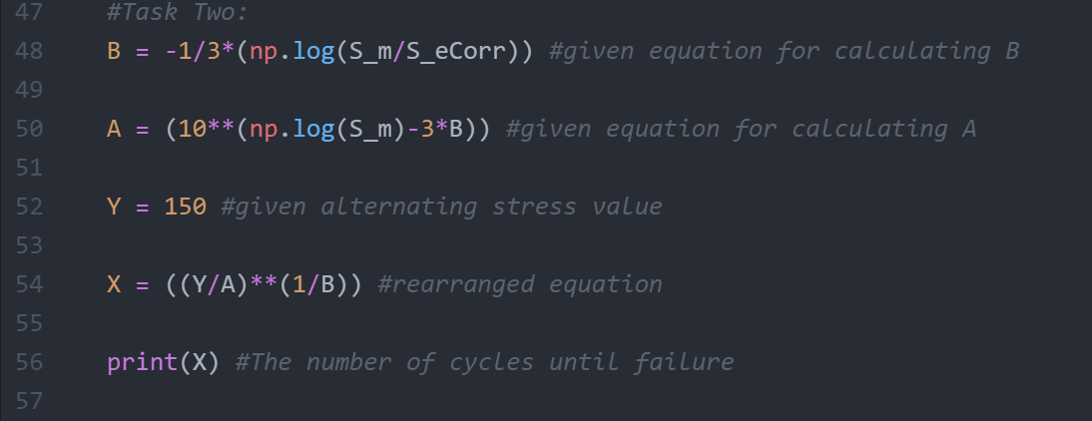

Figure 3 - Python Code Used for Task Two

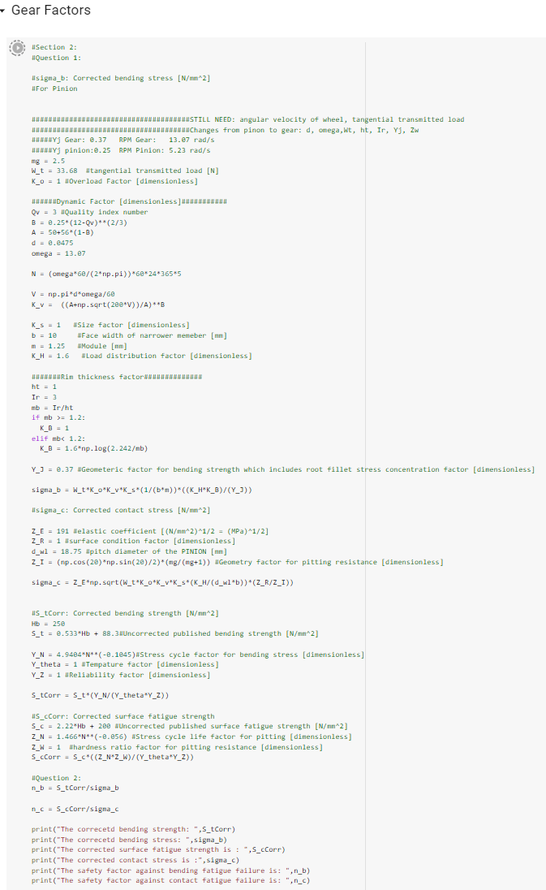

Figure - Python code used to calculate all the stresses, strengths, and safety factors for the gear. A few values are changed within this code to calculate the values for the pinion.

# Appendix B – Updated Drawings

Figure 5 - Exploded gear assembly drawing

Figure 6 - Gear drawing

Figure 7 - Pinion drawing

Figure 8 - Pinion shaft drawing

Figure 9 - Gear shaft drawing

# Appendix C – Excel Spreadsheet calculations



­­­





Figure - Excel Spreadsheet of All Calculated Phase One Values

*The excel ­­spreadsheet was too large to fit in one image. The top speed gradient gets greener as the top speed goes up. Maximum torque is the torque exerted by the gear when the velocity of the car is 0. The effective torque is the maximum torque on the axle minus the torque due to resistance, or in other words, the net torque on the wheel. If it is red/negative, this means that the motor will stall.